Experiment 4 **LCD DISPLAY USING 8051 USING KEIL AND PROTEUS**

**AIM:**

Write an assembly language program for LCD display Using 8051.

**SOFTWARE REQUIRED:**

* Keil software 5.
* Proteus 8 software.

**KEIL PROCEDURE:**

1. Open the software, Click on project and open new version project.

2. Create a new project file

3. Enter AT89C51

4. Click NO

5. Click [Ctrl +N] and Type the code

6. Open project and click Build target

7. Open Build target and open source file and ADD, CLOSE

8. Click build target

9. Next debug start and stop

10. Open peripherals and select port 2

11. Now run the program in Debug

12. Open project and click optional properties and in that give output as hex file.

13.Create Hex file

**PROTEUS SOFTWARE:**

* Open proteus by clicking run as administrator.
* Open new project and enter the file name.
* Click next, next, next and finish.
* Click P symbol and search keyword and place the required components

The components required are:

* AT89C51
* LM016L
* Connecting pin number 7 from the LCD (LM016L) to pin 1 in the At89c51
* Likewise, connect pin 8, 9, 10, 11, 12, 13 & 14 from the LCD(LM016L) to the pins 2, 3, 4, 5, 6, 7 & 8 of the AT89c51
* Connecting pin 4 from the LCD (LM016L) to the pin 21 in the AT89c51
* Likewise, connect pins 5 & 6 in the LCD (LM016L) to the pins 22 & 23 in the AT89c51
* Select the hex file

Start the simulation process

**PROGRAM:**

ORG 0000H

RS BIT P2.0

RW BIT P2.1

EN BIT P2.2

MOV A,#38H

ACALL CMD

MOV A,#0EH

ACALL CMD

MOV A,#80H

ACALL CMD

MOV A,#06H

ACALL CMD

MOV A,#'S'

ACALL DATA1

MOV A,#'A'

ACALL DATA1

MOV A,#'V'

ACALL DATA1

MOV A,#'E'

ACALL DATA1

MOV A,#'E'

ACALL DATA1

MOV A,#'T'

ACALL DATA1

MOV A,#'H'

ACALL DATA1

MOV A,#'A'

ACALL DATA1

MOV A,#0C0H

ACALL CMD

MOV A,#'U'

ACALL DATA1

MOV A,#'N'

ACALL DATA1

MOV A,#'I'

ACALL DATA1

MOV A,#'V'

ACALL DATA1

MOV A,#'E'

ACALL DATA1

MOV A,#'R'

ACALL DATA1

MOV A,#'S'

ACALL DATA1

MOV A,#'I'

ACALL DATA1

MOV A,#'T'

ACALL DATA1

MOV A,#'Y'

ACALL DATA1

CMD:ACALL READY

MOV P1,A

CLR RS

CLR RW

SETB EN

ACALL DELAY

CLR EN

RET

READY:SETB P1.7

CLR RS

SETB RW

H:CLR EN

ACALL DELAY

SETB EN

JB P1.7,H

RET

DATA1:ACALL READY

MOV P1,A

SETB RS

CLR RW

SETB EN

ACALL DELAY

CLR EN

DELAY:MOV R4,#180

HERE1:MOV R3,#255

HERE2:DJNZ R3,HERE2

DJNZ R4,HERE1

RET

END

**Circuit Diagram:**

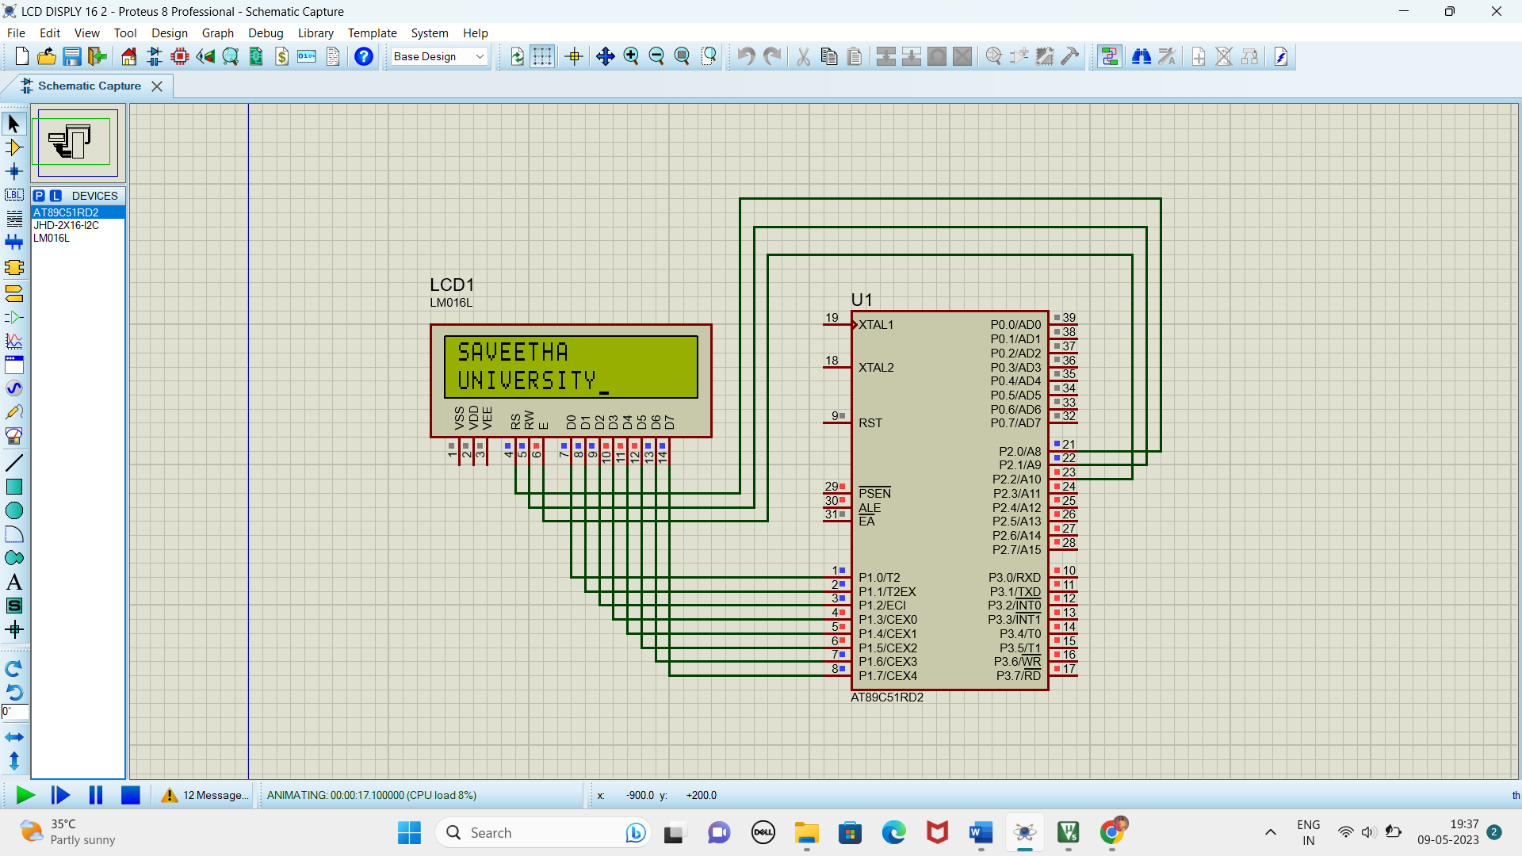

**RESULT:**

Thus the program has been successfully verified and executed.